# DAD 220 Project One Template

Complete these steps as you work through the directions for Project One. Replace the bracketed text with your screenshots and brief explanations of the work they capture. Each screenshot and its explanation should be sized to approximately one-quarter of the page with the description written below the screenshot. Follow these rules for each of the prompts and questions below. Review the example document in the Supporting Materials section of the Project One Guidelines and Rubric for assistance.

## Step One: Create a Database

1. In your online IDE (Codio), **create a database schema** called QuantigrationUpdates that will hold tables by using SQL commands.
   1. List out the database name on the screen.
   2. Provide the SQL commands you ran against MySQL to complete this step.

1. Used mysql then SHOW Databases to show existing databases then created database by using CREATE Database QuantigrationUpdates then used the SHOW command again to show that database was created.
2. Connect to the QuantigrationUpdates schema. Using the ERD as a reference, **write SQL commands to create** the following **tables** with the appropriate attributes and keys to demonstrate relationships based on the ERD.
   1. A table named Customers to store customer information with a primary key of Customer ID. Provide the SQL commands you ran against MySQL to complete this step.

I used the command USE to enter the QuantigrationUpdates database followed by CREATE TABLE Customers and inserted the values needed to create the table along with creating the primary key Customer_ID. I used the DESCRIBE command to show the creation of said table

* 1. A table named Ordersto store order information with a primary key of Order ID and a foreign key of Customer ID. Provide the SQL commands you ran against MySQL to complete this step.

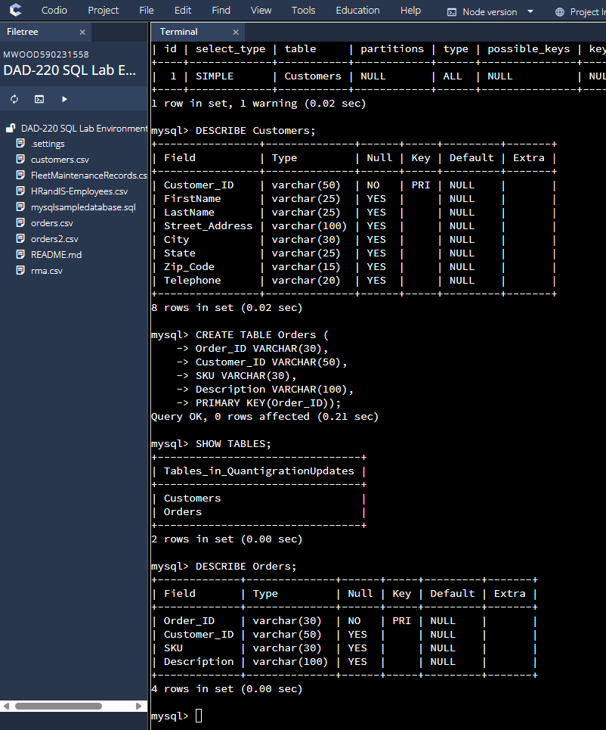

I used the same steps as I did when I created the Customers table as shown above in screenshot.

* 1. A table named RMA to store RMA information with a primary key of RMA ID and a foreign key of Order ID. Provide the SQL commands you ran against MySQL to complete this step.

I used the same steps creating the RMA table and used the DESCRIBE command to show the attributes within the table as I did in prior instances.

## Step Two: Load and Query the Data

1. **Import** the **data** from each file **into tables.** 
   1. Use the QuantigrationUpdates database, the three tables you created, and the three CSV files preloaded into Codio.
   2. Use the import utility of your database program to load the data from each file into the table of the same name. Perform this step three times, once for each table.
   3. Provide the SQL commands you ran against MySQL to complete this step.

By using LOAD DATA INFILE I was able load existing data into the newly created tables by using the INTO TABLE command setting the parameters by using FIELD and LINES TERMINATED BY commands.

1. **Write basic queries** against the imported tables to organize and analyze the targeted data**.** For each query, replace the bracketed text with a screenshot of the query and its output. Also, include a one- to three-sentence description of the output.
   1. Write a SQL query that returns the count of orders for customers located only in Framingham, Massachusetts.
      1. This query will use a table join between the Customers and Orders tables. The query will also use a WHERE clause.
      2. How many records were returned?

By using SELECT COUNT(*) and using the INNER JOIN to put the Customers and Orders Tables together to give a complete count then setting the parameters of the search within the WHERE command to the city and state of Framingham, Massachusetts and it returned 505 products.

* 1. Write a SQL query to select all of the customers located in Massachusetts.
     1. Use a WHERE clause to limit the number of records in the Customers table to only those who are located in Massachusetts.
     2. How many records were returned?

Using the SELCT COUNT(*) counts the customers. FROM pulls data from the Table named in this case Customers. Using WHERE sets the parameters where and what data will be collected. The ending result is 982 customers in Massachusetts.

* 1. Write a SQL query to insert four new records into the Orders and Customers tables using the data below:

**Customers Table**

| **CustomerID** | **FirstName** | **LastName** | **StreetAddress** | **City** | **State** | **ZipCode** | **Telephone** |
| --- | --- | --- | --- | --- | --- | --- | --- |
| 100004 | Luke | Skywalker | 15 Maiden Lane | New York | NY | 10222 | 212-555-1234 |
| 100005 | Winston | Smith | 123 Sycamore Street | Greensboro | NC | 27401 | 919-555-6623 |
| 100006 | MaryAnne | Jenkins | 1 Coconut Way | Jupiter | FL | 33458 | 321-555-8907 |
| 100007 | Janet | Williams | 55 Redondo Beach Blvd | Torrence | CA | 90501 | 310-555-5678 |

I used the INSERT command to set the attributes that would be inserted into the Customers table then added the values to fill the named table with the required data.

**Orders Table**

| **OrderID** | **CustomerID** | **SKU** | **Description** |
| --- | --- | --- | --- |
| 1204305 | 100004 | ADV-24-10C | Advanced Switch 10GigE Copper 24 port |
| 1204306 | 100005 | ADV-48-10F | Advanced Switch 10 GigE Copper/Fiber 44 port copper 4 port fiber |
| 1204307 | 100006 | ENT-24-10F | Enterprise Switch 10GigE SFP+ 24 Port |
| 1204308 | 100007 | ENT-48-10F | Enterprise Switch 10GigE SFP+ 48 port |

I used the INSERT command to use the correct table and attributes then filled the values with the required data.

* 1. In the Customers table, perform a query to count all records where the city is Woonsocket and the state is Rhode Island.
     1. How many records are in the Customers table where the field "city" equals "Woonsocket"?

[Insert screenshot and response here.

Using the SELECT command along with the FROM command then the WHERE command selects the COUNT command from the named table within the parameters stated by the WHERE command.

* 1. In the RMA database, update a customer's records.
     1. Write a SQL statement to select the current fields of status and step for the record in the RMA table with an OrderID value of "5175".
        1. What are the current status and step?

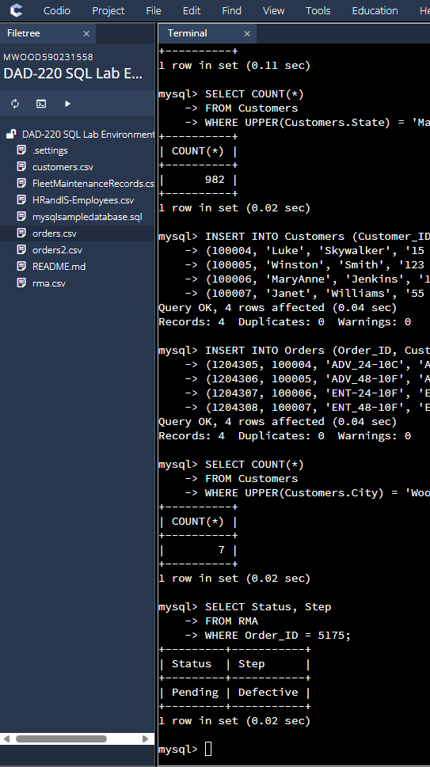

The current status and step of order 5175 is Pending and Defective.

* + 1. Write a SQL statement to update the **status** and **step** for the **OrderID**, 5175 to **status** = "Complete" and **step** = "Credit Customer Account".
       1. What are the updated **status** and **step** values for this record?

I used the UPDATE command to update RMA attributes to Complete and Credit Customer Account in order 5175 then used the SELECT command to choose Status, Step then the FROM RMA then the WHERE command to choose order 5175 and display the new status and step attributes.

* 1. Delete RMA records.
     1. Write a SQL statement to delete all records with a reason of "Rejected".
        1. How many records were deleted?

Nothing was affected according to the results by using the DELETE command within the parameters of ‘Rejected’.

1. **Update your existing tables** from "Customer" to "Collaborator" using SQL based on this change in requirements. Copy and paste the SQL you write to do the following action:
   1. Rename all instances of "Customer" to "Collaborator".

By Using the ALTER command then the RENAME command allows me to change the name of the table.

1. **Create** an **output file** of the required query results. Write a SQL statement to list the contents of the **Orders** table and send the output to a file that has a CSV extension.

I used the SELECT command to choose data then the FROM command to choose the correct table then the INTO to put file into the OUTFILE of my choosing and the parameters in the FIELDS and LINES commands.